~$500 Healthy Diet (For Obesity)
(Including Breakfast, Lunch and Dinner Plus Snack)

- Oats 1.6Kg - Enough for 30 meals
  - Brought from Mong Kok
  - Approximately $18 per 1kg
  - Price: $36

- Chicken Chops (Large) 25 Pieces – Enough for 30 meals
  - Brought from market
  - Approximately ~ $11 per Piece
  - Price: $275
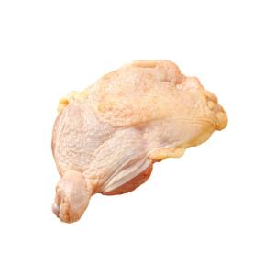

- Marie Biscuit 4 Packets - Enough for 120 meals
  - Brought from welcome supermarket
  - Approximate $26 for 2 packets
  - Price: $72

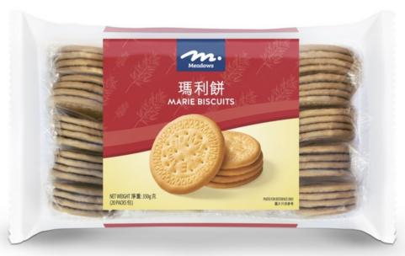

- Vegetables 6kg - Enough for 30 meals
  - Brought from market
  - Approximate $8 per kg
  - Price $48

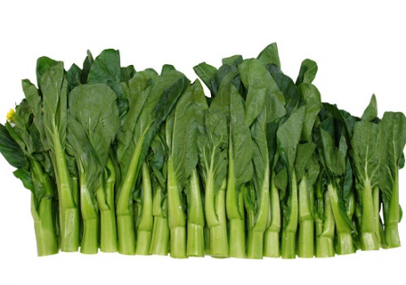

- Best Mart 360 Premium Thai Fragrant Rice 5kg – Enough for 30 meals
  - Brought from Best Mart 360
  - Approximately ~ $49 per packet
  - Price: $49
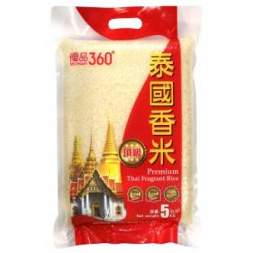

- Longevity Filled Evaporated Milk 3 cans 400GM
  - Brought from welcome supermarket
  - Approximate $11 per can
  - Price: $33

Total Price: Approximate $513 (All in terms of Hong Kong Dollars)
Updated: 16th April 2025 price subject to change

Ingredients And Menus (Total 90 Meals Plus Snack)
3 Meals Per Day (Breakfast, Luch and Dinner Plus Snack) for 90 days

These ingredients are based on portions. In case you don’t how to accurately divide it into portion. You can use a balance to weight the net weight of the ingredients and then divide it into portions base on the net weight.

- Breakfast meal – (30 meals) (Served for Breakfast)

- Fish or Meat (Fresh) 1 onces (30 grams).
- Bread 2 slices or Oat meal (8 spoonfull of dried Oats equilvanent to 40 grams, 40ml of milk evaporated milk with sugar ).

- Breakfast 10:00AM Snack – (30 meals) (Served for Breakfast 10:00AM)

- Marie Biscuit (3 pieces ~ 15grams).

- Luch meal– (30 meals) (Served for Lunch)

- Broth Soup (Optional).
- Fish or Meat 3 onces (90 grams)
- Vegetables not less than 2/3 (two third fractional 100gram) Bowl.
- Rice 1 2/5 (one and two fifth fractional) Bowl.

- Afternoon Tea – (30 meals) (Served for Afternoon Tea)

- Marie Biscuit (3 pieces).

- Dinner – (30 meals) (Served for Dinner)

- Broth Soup (Optional).
- Fish or Meat 3 onces (90 grams)
- Vegetables not less than 2/3 (two third fractional 100gram) Bowl.
- Rice 1 2/5 (one and two fifth fractional) Bowl.

- Before Bed Snack – (30 meals) (Served for Before Bed)

- Marie Biscuit (3 pieces).

- Everyday
  - Only allow 3 tea spoon of oil.
  - One Bowl equals 300 milligrams (300 grams).

